Web Technologies Coursework 2 Report

1. The goal of this assignment was to create a blog that would allow the user to create, edit and delete a post. The blog that I have made consists of these features. It is simple and easy to use as there Is no clutter on the screen. The user can enter a title and a body of information which can then be posted to the screen. This post can then be deleted or edited depending on if the user wants to change something.
2. The server.js file and the html file will be created first, followed up by the user application file. Everything being used through the client side will be transferred to the server side and then stored in a mongodb. The date and time of each post will be recorded and if a user wants to edit or delete a post, the changes will also take effect in the database as well. Functions will be used for adding, deleting and editing a post. An update function will be once to save the changes made after a post is edited. Each post will also get a unique Id that will separate them from one another.

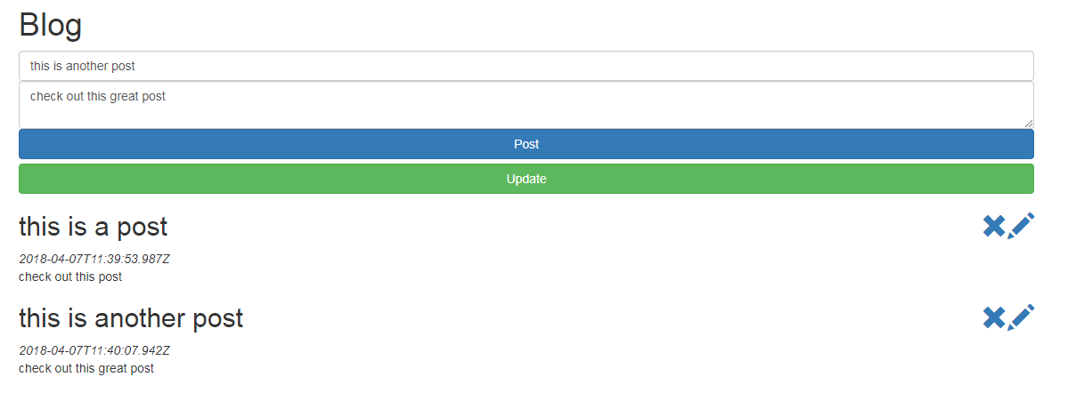

The user can enter a title and body for the post. They can then click post to submit it and then edit that post using the pencil icon which will put the posts contents back into the title and body boxes where they can be changed. The update button can then be clicked to save the changes made to the post. The user can delete the post using the cross icon.

1. The website follows most of the requirements that were set out. It has client side and server-side elements. Users can add multiple blog posts and are able to view and edit them. They can then delete an existing blog post. The server can load up the user interface and does provide a create, read, update and delete API that the client element utilises in providing the blogs features. Compared to other blog platforms, this website is very basic in what it can do since additional functionality’s have not been added. It is limited to one page, so it is basic. A level of security could have been added to the website to make it safer to use. More pages could have been added to give a wider variety of user interaction. The look of the website could have been improved as it looks quite bland. However, it is easy to see what is going on.
2. The main challenge for me was getting the website to work with the database. When trying to delete an older post, it would struggle to find it in the database. I managed to get it working in the end with the use of an Id so that every post was unique. I learned how to code a server and run it through node.js and I also learnt how install packages and make use of them while coding. I then found out how use mongodb to store the posts for the website so that information would not get lost and it could be easily changed.